Lab Assessment-9

Q)

import java.io.*;

public class Reverse {

public static void main(String[] args) {

FileInputStream fis = null;

RandomAccessFile raf = null;

String characterEncoding = "hi";

if(args.length==3) {

characterEncoding = args[2];

}

try{

File in = new File(args[0]);

fis = new FileInputStream(in);

Reader r = new InputStreamReader(fis,characterEncoding);

File out = new File(args[1]);

raf = new RandomAccessFile(out, "rw");

raf.setLength(in.length());

char[] buff = new char[1];

long position = in.length();

while((r.read(buff))>-1) {

Character c = buff[0];

String s = c+"";

byte[] bBuff = s.getBytes(characterEncoding);

position = position-bBuff.length;

raf.seek(position);

raf.write(bBuff);

}

} catch (Exception e) {

e.printStackTrace();

} finally {

try {

fis.close();

} catch (Exception e2) {

}

try {

raf.close();

} catch (Exception e2) {

}

}

}

}

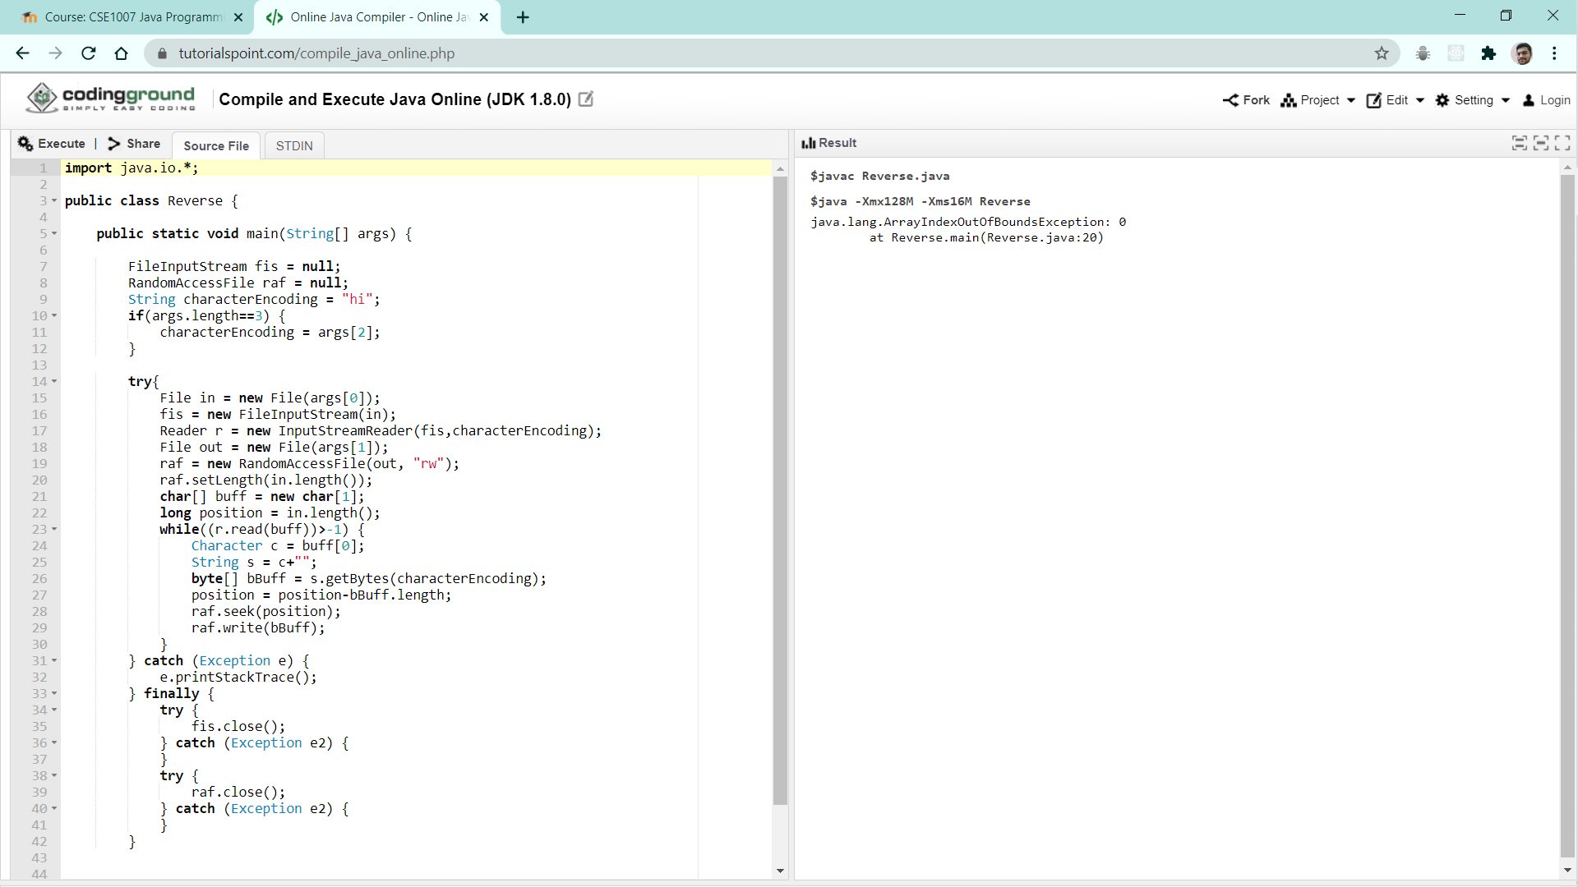

Q)

import java.util.*;

import java.io.*;

public class Exercise58 {

public static void main(String[] args){

Scanner in = new Scanner(System.in);

System.out.print("Input a Sentence: ");

String line = in.nextLine();

String upper_case_line = "";

Scanner lineScan = new Scanner(line);

while(lineScan.hasNext()) {

String word = lineScan.next();

upper_case_line += Character.toUpperCase(word.charAt(0)) + word.substring(1) + " ";

}

System.out.println(upper_case_line.trim());

}

}

Q)

import java.util.Scanner;

import java.io.*;

public class LowercaseFileConverter2

{

public static void main(String[] args)throws IOException

{

String filename;

String message;

String filename2;

Scanner keyboard = new Scanner(System.in);

System.out.print("Enter the filename: ");

filename = keyboard.nextLine();

FileWriter fwriter = new FileWriter(filename);

PrintWriter outputFile = new PrintWriter(fwriter);

System.out.println("Enter a message: ");

message = keyboard.nextLine();

outputFile.println(message);

outputFile.close();

System.out.println("Enter the name of the second file: ");

filename2 = keyboard.nextLine();

FileReader freader = new FileReader(filename2);

BufferedReader inputFile = new BufferedReader(freader);

String str;

str = inputFile.readLine();

while (str != null)

{

System.out.println(str);

String upper = message.toLowerCase();

str = inputFile.readLine(lower);

}

inputFile.close();

}

}

Q)

import java.io.*;

public class Tester {

private static final String FILE_PATH = "data.txt";

public static void main(String args[]) throws IOException {

FileUtil fileUtil = new FileUtil(FILE_PATH);

System.out.println("No. of characters in file: " + fileUtil.getCharCount());

}

}

class FileUtil {

static BufferedReader reader = null;

public FileUtil(String filePath) throws FileNotFoundException {

File file = new File(filePath);

FileInputStream fileStream = new FileInputStream(file);

InputStreamReader input = new InputStreamReader(fileStream);

reader = new BufferedReader(input);

}

public static int getCharCount() throws IOException {

int charCount = 0;

String data;

while((data = reader.readLine()) != null) {

charCount += data.length();

}

return charCount;

}

}

Q)

import java.io.*;

public class FileMerge

{

public static void main(String[] args) throws IOException

{

// PrintWriter object for file3.txt

PrintWriter pw = new PrintWriter("file3.txt");

// BufferedReader object for file1.txt

BufferedReader br = new BufferedReader(new FileReader("file1.txt"));

String line = br.readLine();

// loop to copy each line of

// file1.txt to file3.txt

while (line != null)

{

pw.println(line);

line = br.readLine();

}

br = new BufferedReader(new FileReader("file2.txt"));

line = br.readLine();

// loop to copy each line of

// file2.txt to file3.txt

while(line != null)

{

pw.println(line);

line = br.readLine();

}

pw.flush();

// closing resources

br.close();

pw.close();

System.out.println("Merged file1.txt and file2.txt into file3.txt");

}

}